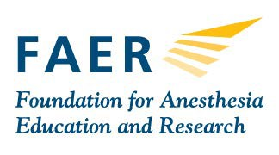
Swimming with Sharks:

How Anesthesiologist Inventors

Can Move Their Ideas Forward

Presentation Proposal Submission Form

ANESTHESIOLOGY® 2018

Saturday, October 13, 2018
1 – 3 p.m.
San Francisco Moscone Center
San Francisco, CA

Description: ANESTHESIOLOGY has a long history of innovation, entrepreneurship and close interactions between academicians, private practitioners and industry to bring new concepts to the clinical arena and better care for our patients. Using a panel format, inventors will present their ideas to industry experts who are involved in the development of such innovations. This session will educate the audience regarding the multiple steps involved in the process and provide resources for those who hope to advance their practice through innovation.

If you are interested in applying to be one of four inventors to stand in the spotlight and present your innovative idea to a panel of successful inventors and investors, please complete this form and submit it to FAER@faer.org by the June 15, 2018 deadline.

Presenter’s Name:

Presenter’s Professional Title: Institution/Organization: Email Address:
Phone Number:

Provide a brief description of your invention, including the stage of development.

Note:
IP for your invention should be in hand.
All types of inventions (devices, drugs, systems, etc.) will be considered.
The invention should be beyond the idea stage. For example, the presenter should have data to defend a patent or prototype available.

